***Name :***- Girishkumar Purushottam Naranje

***Roll No.*** :- 2051

***PRN No.*** :- 200941281049

**OS Assignments**

***Assignment 1 :-***

***Que 1***.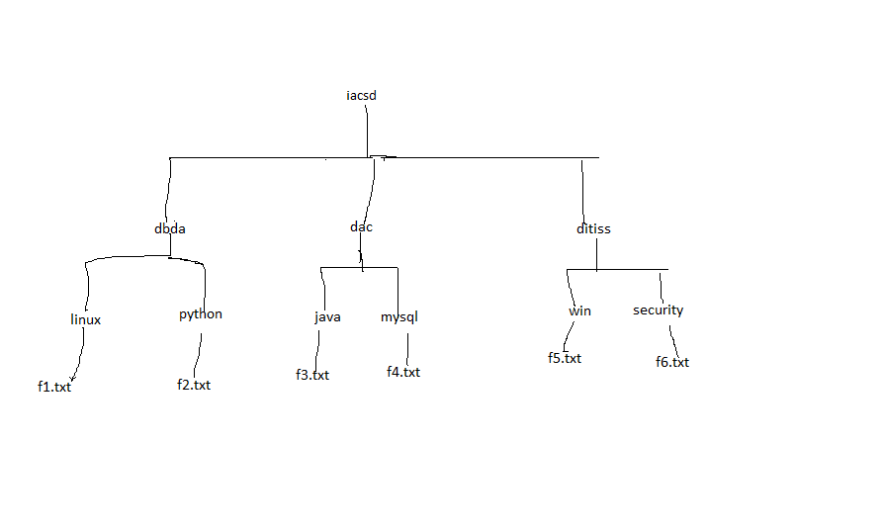***Ans :-***

***Commands :-***

[user1@localhost ~]$ mkdir iacsd

[user1@localhost iacsd]$ makdir dbda

[user1@localhost iacsd]$ makdir dac

[user1@localhost iacsd]$ makdir ditiss

[user1@localhost dbda]$ mkdir linux

[user1@localhost dbda]$ mkdir python

[user1@localhost dac]$ mkdir java

[user1@localhost dac]$ mkdir mysql

[user1@localhost ditiss]$ mkdir win

[user1@localhost ditiss]$ mkdir security

[user1@localhost linux]$ nano f1.txt

[user1@localhost python]$ nano f2.txt

[user1@localhost java]$ touch f3.txt

[user1@localhost mysql]$ touch f4.txt

[user1@localhost win]$ touch f5.txt

[user1@localhost security]$ touch f6.txt

***Output:- 1-***

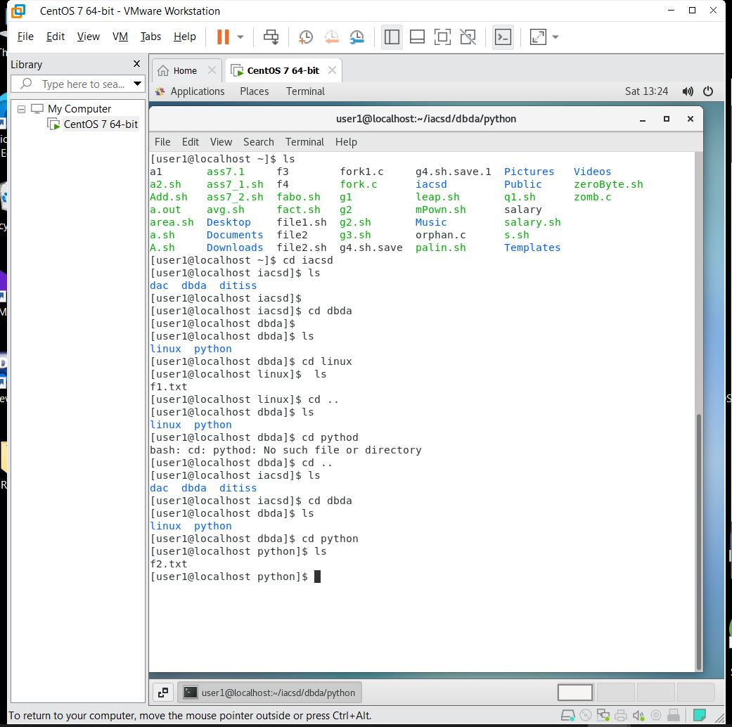

***Output:- 2-***

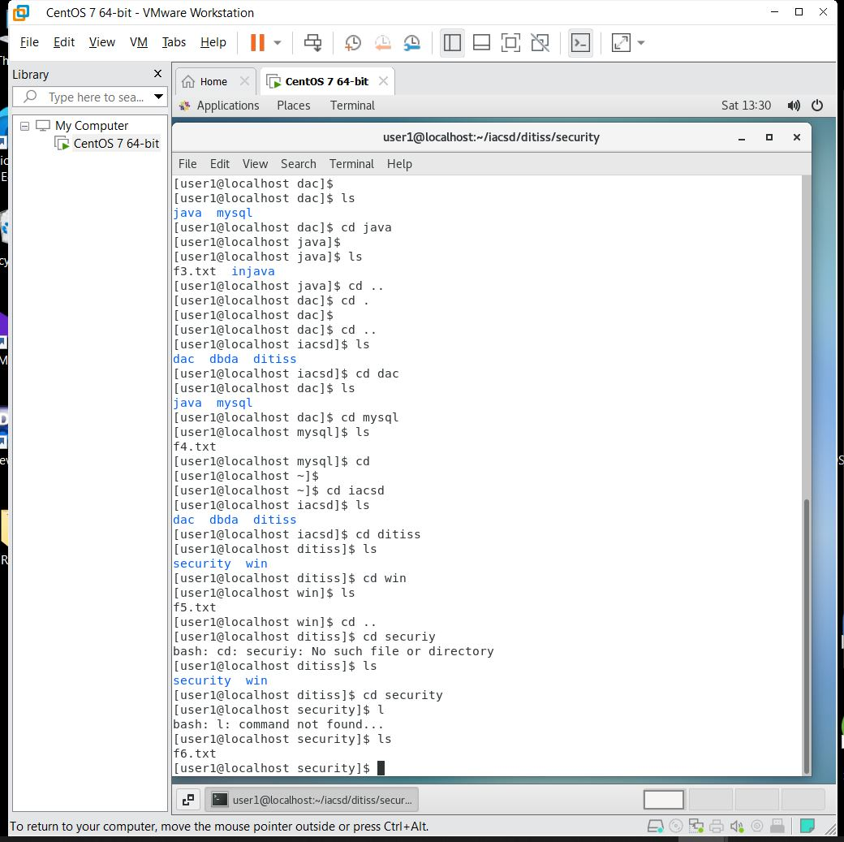

***Assignment 2 :-***

***Que 1***.

1. Create user

Ram

Sam

Chinky

1. Create group

Cdac

Iacsd

1. Add user ram in cdac
2. Add user sam in iacsd
3. Create file f1 ,f2 ,f3 , f4 in /root with root user
4. Ram should have rwx on f4
5. Chinky should be user owner for file f1
6. Sam should be userowner for f2
7. Cdac should be groupowner for f3
8. Cdac should have read permission on f3
9. Iacsd should have full access on f4

***Ans :-***

***Commands :-***

[user1@localhost ~]$ useradd Ram

[user1@localhost ~]$ useradd Sam

[user1@localhost ~]$ useradd Chinky

[user1@localhost ~]$ sudo groupadd Cdac

[user1@localhost ~]$ sudo groupadd Iacsd

[user1@localhost ~]$ sudo usermod -aG Cdac Ram

[user1@localhost ~]$ sudo usermod -aG Iacsd Sam

[root@localhost user1]# touch f1 f2 f3 f4

[root@localhost ~]# chmod u+rwx f4

[root@localhost ~]# chown Chinky f1

[root@localhost ~]# chown Sam f2

[root@localhost ~]# chgrp Cdac f3

[root@localhost ~]# chmod g+r f3

[root@localhost ~]# chgrp Iacsd f4

***Output:-***

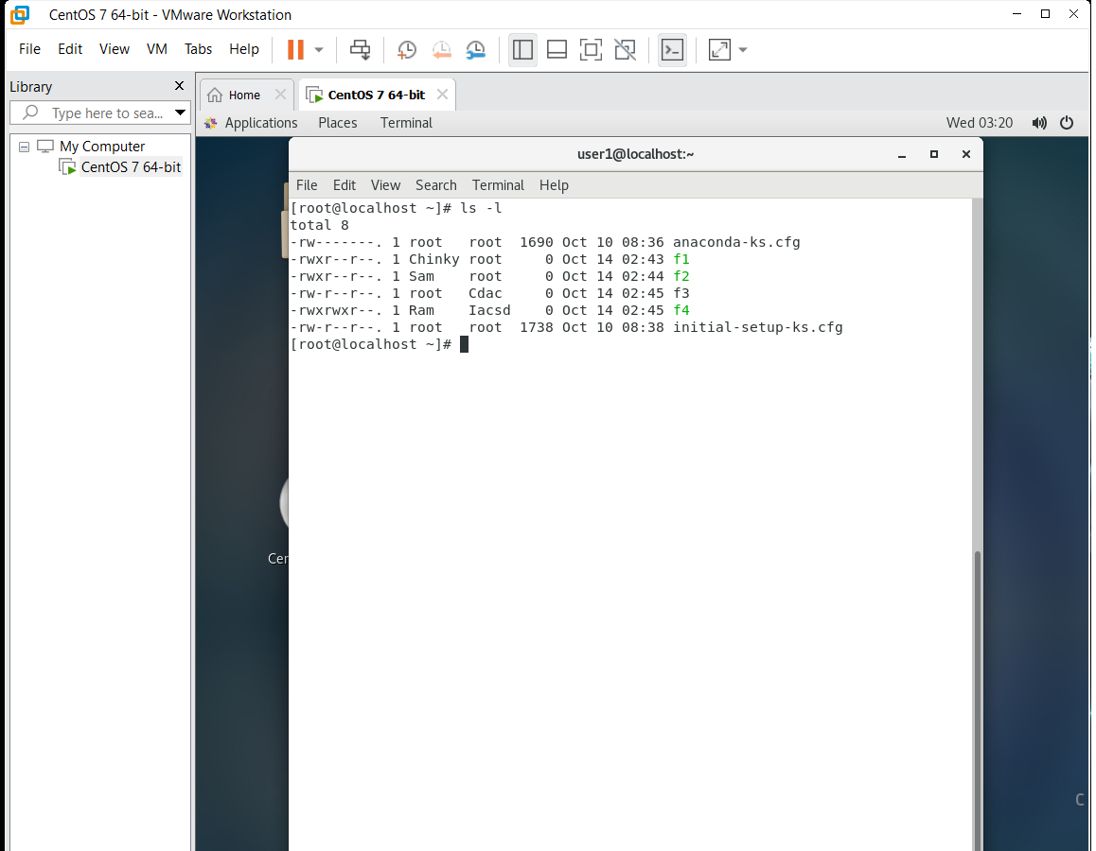

***Assignment 3 :-***

***Que 1***.

1. Login as user student
2. Create file data.dat which is holding information about student like

First name:last name:roll no.:branch:city

ram:kumar:40:dbda:pune

1. Sort student with roll no and save in file f1.txt
2. Count how many students are there

***Ans :-***

***Commands :-***

[root@localhost ~]# su student

[student@localhost ~]$ nano data.dat

[student@localhost ~]$ sudo sort -k 4 data.dat > fi.txt

***Output:-***

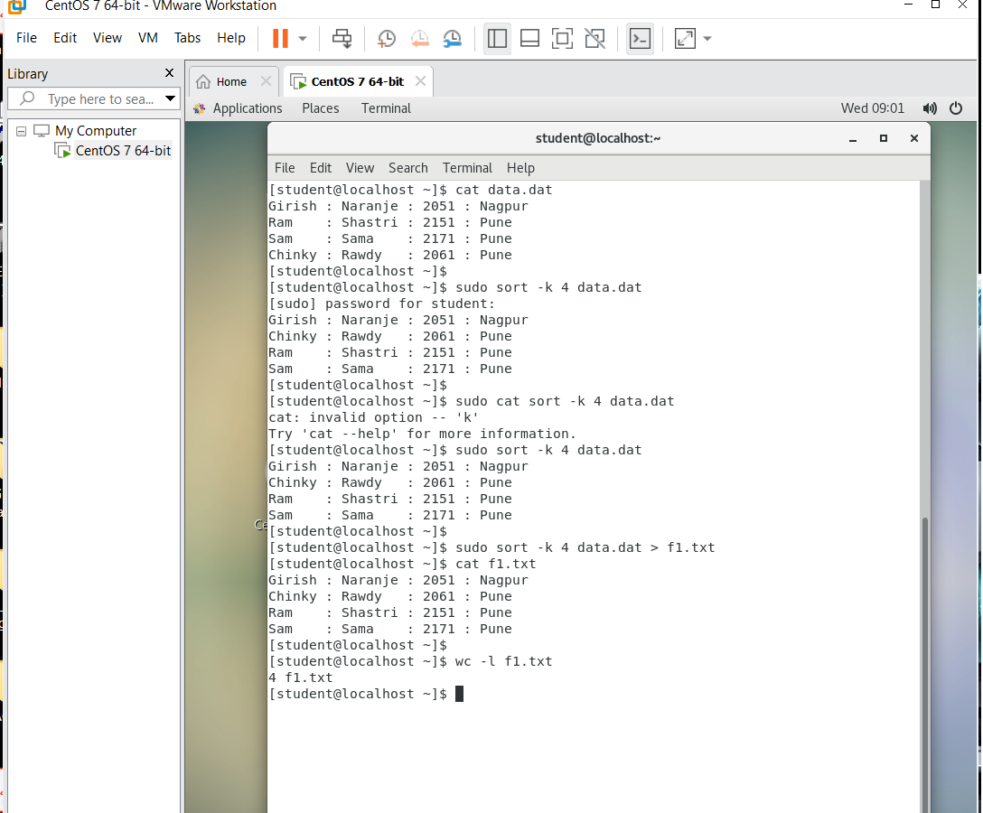

***Assignment 4 :-***

***Que 1***.Write a shell script to calculate salary from given basic.

Salary = basic + dp + da +hra +ma –pf

basic – to be taken as input

dp - 50 % of basic

da - 35 % of (basic + dp)

hra - 8 % of (basic + dp)

ma - 3 % of (basic + dp)

pf - 10% of (basic + dp)

***Ans:-***

***Code:-***

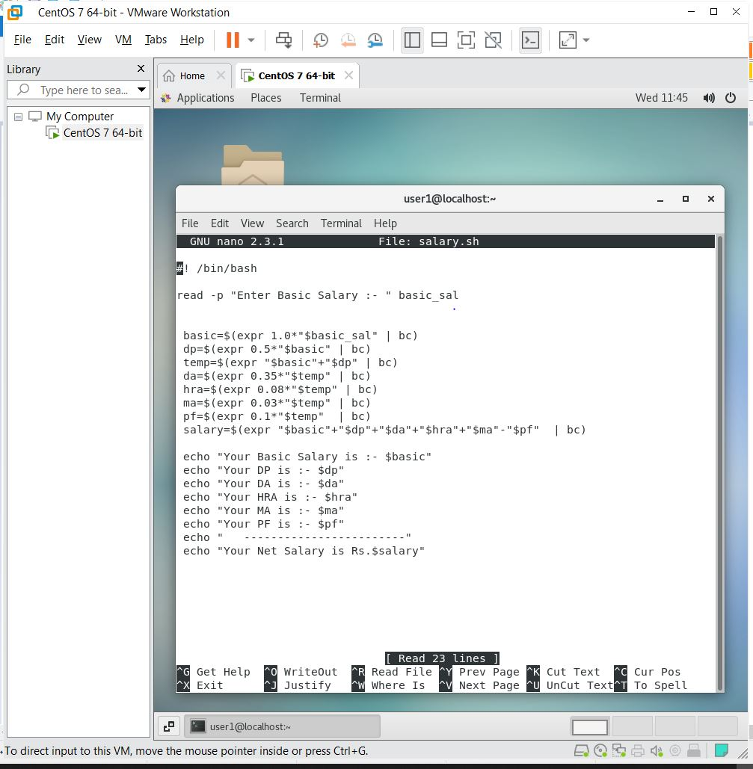

***Output:-***

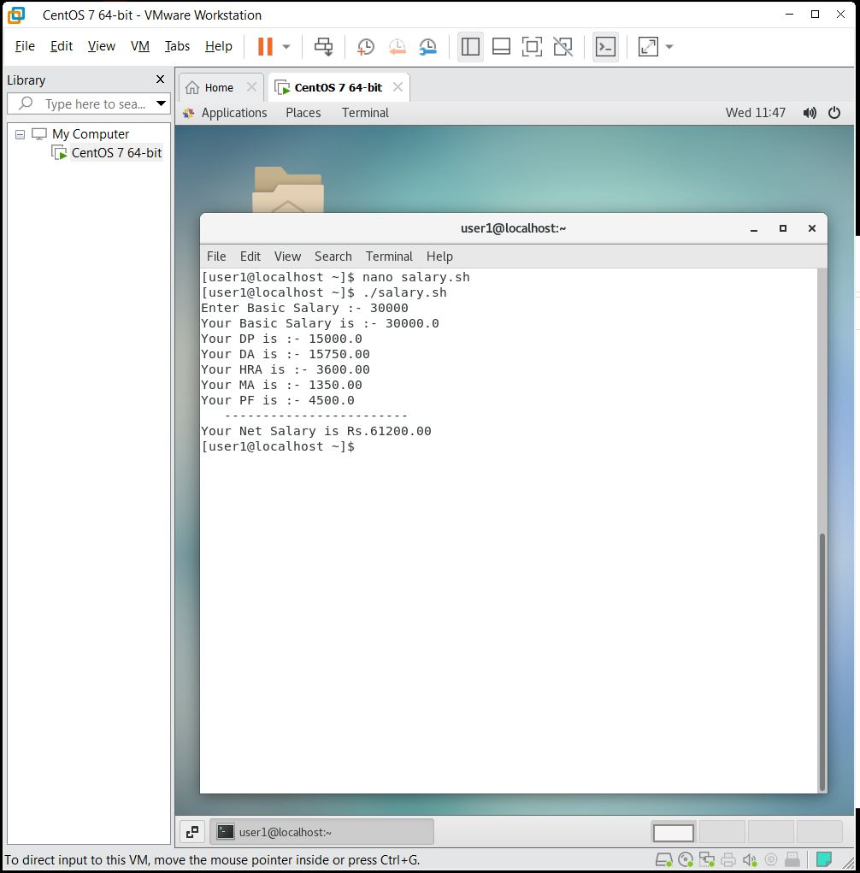

***Que 2***. Accept 2 numbers from user and print addition , subtraction,multiplication Division.

***Ans:-***

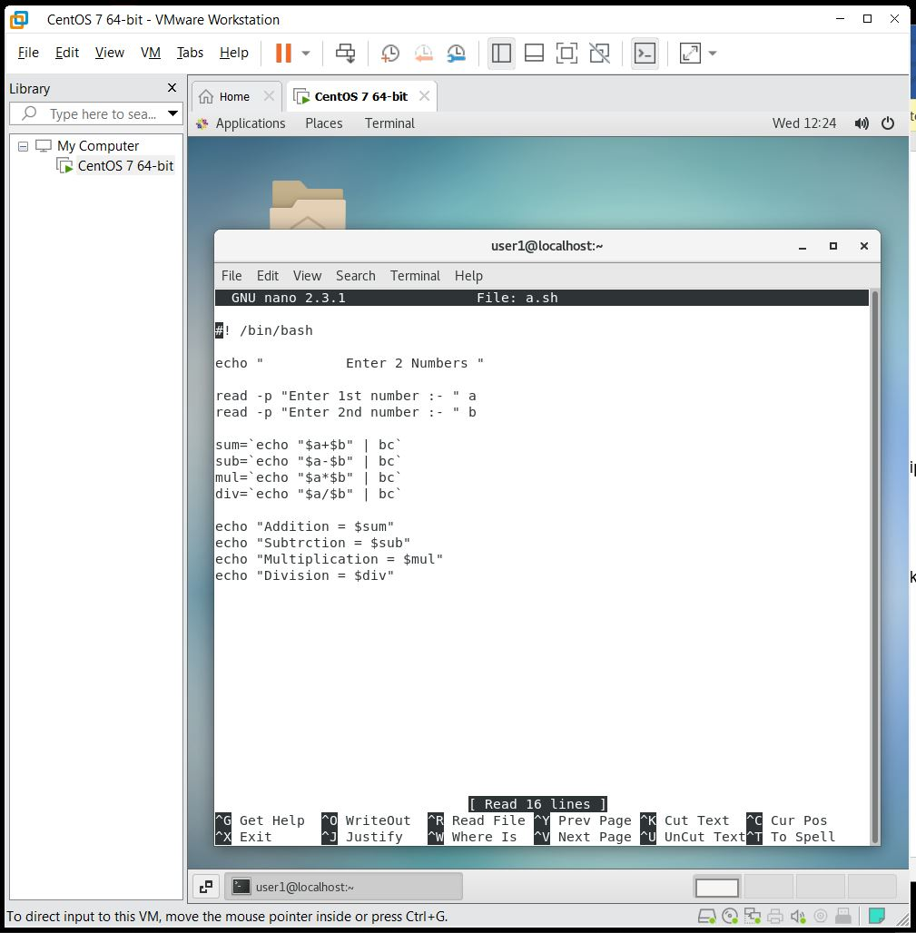

***Output:-***

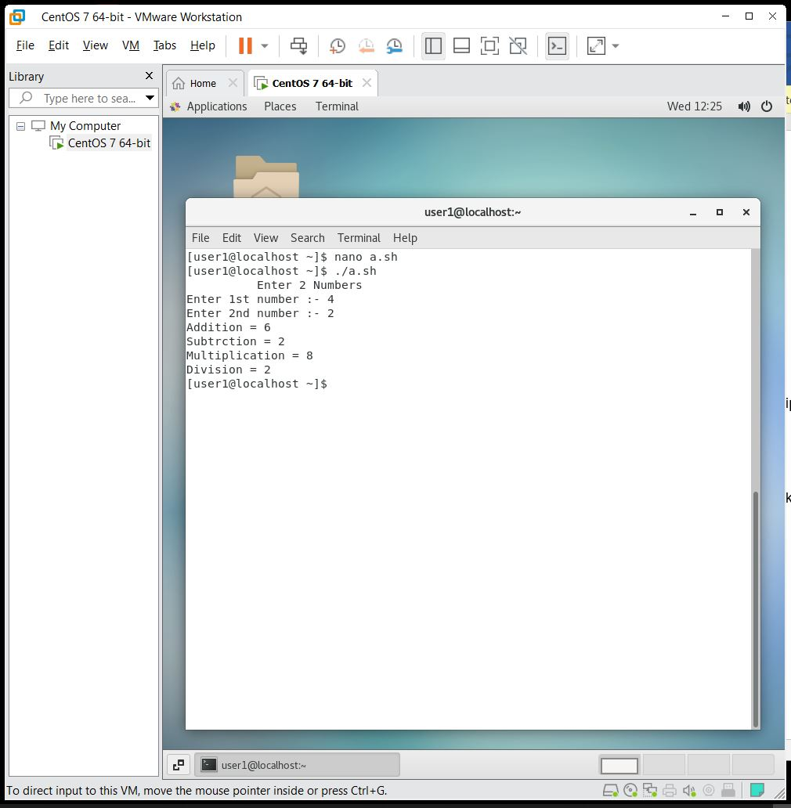

***Que 3.*** Accept file name from user and print how many lines it’s having

***Ans:-***

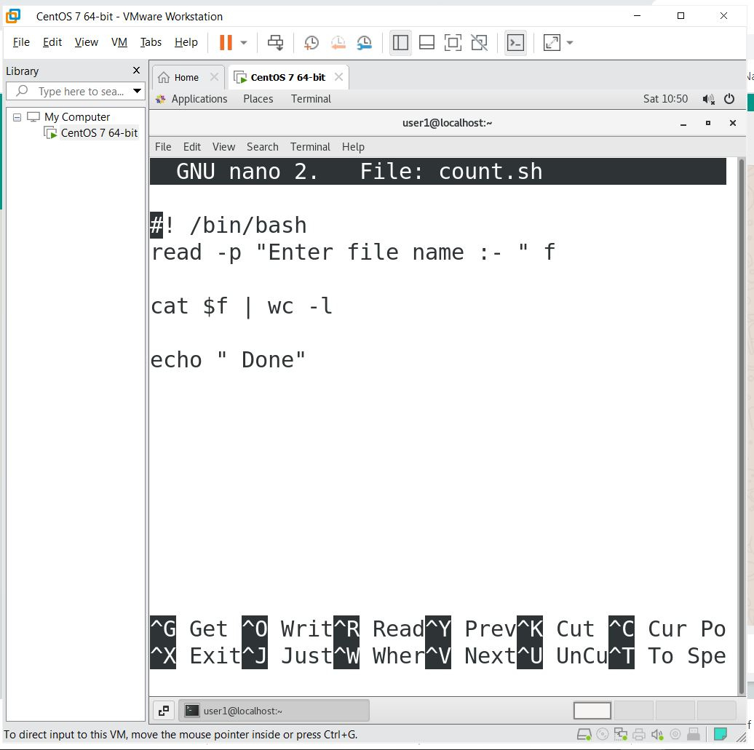

***Output:-***

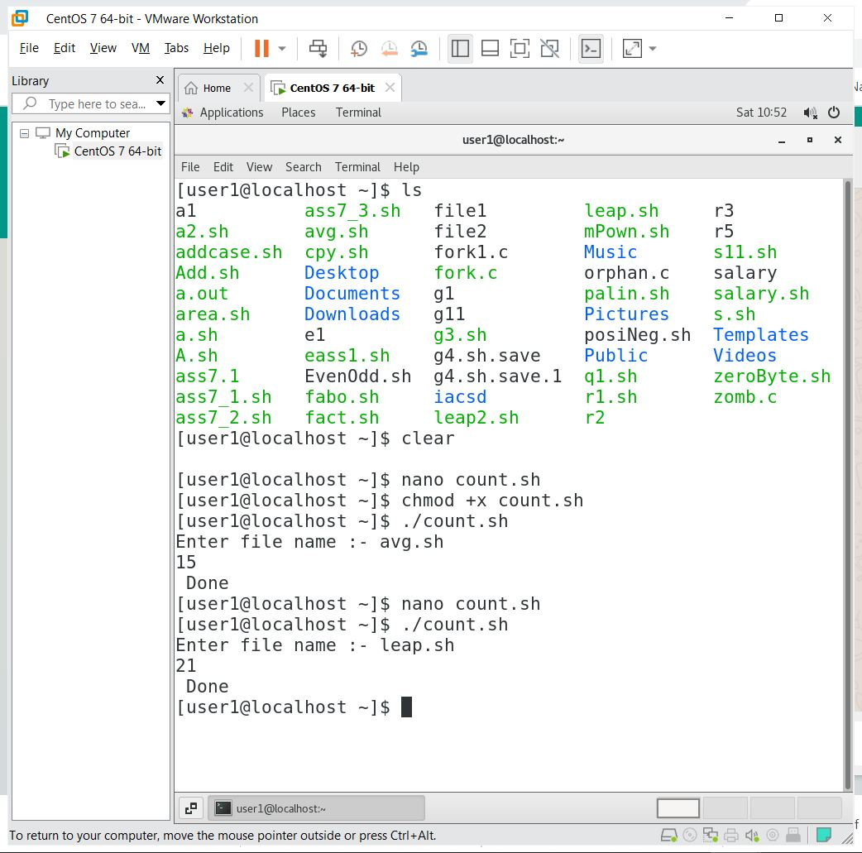

***Que 4.***Write a shell script to calculate the area of rectangle. It should take the value from the command line.

***Ans:-***

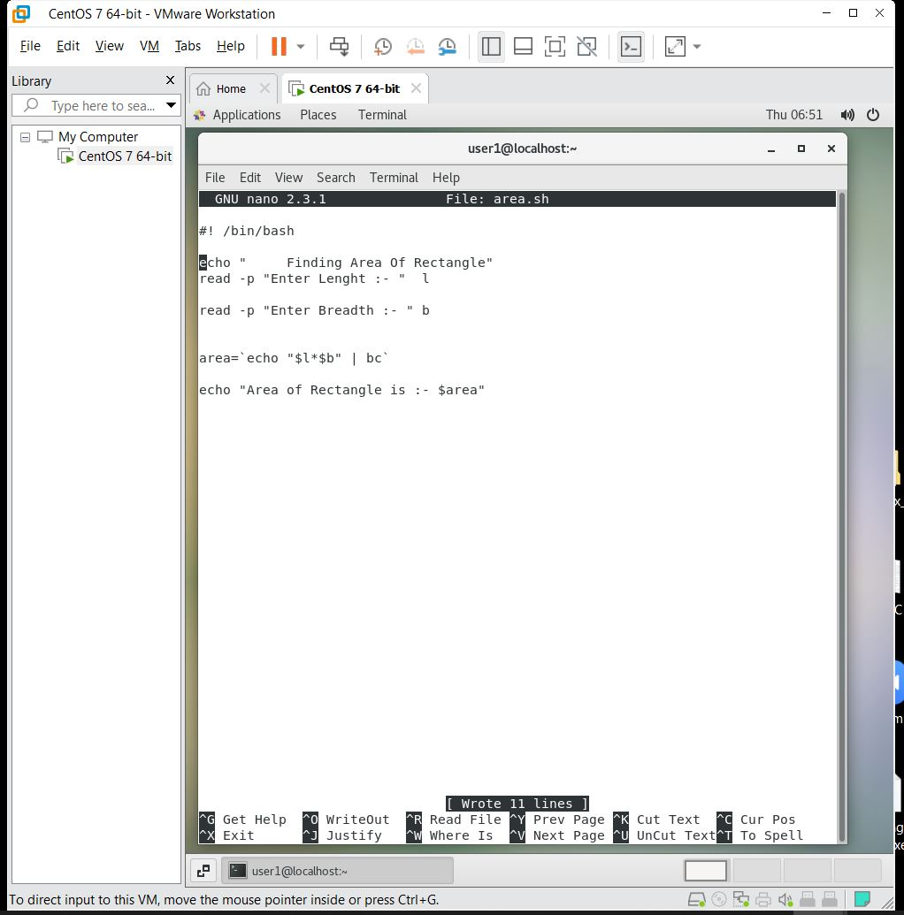

***Output:-***

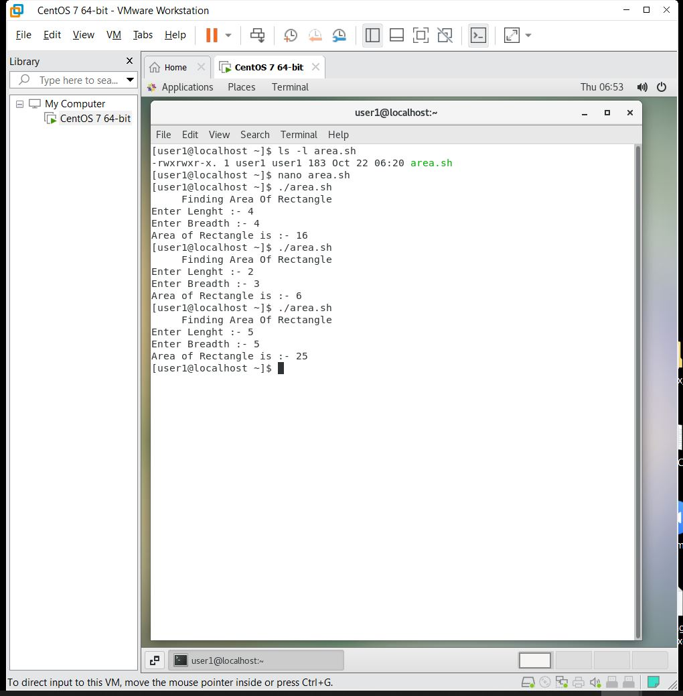

***Assignment 5 :-***

***Que 1***. Write a shell script to check whether a given number is positive or negative or zero.

***Ans:-***

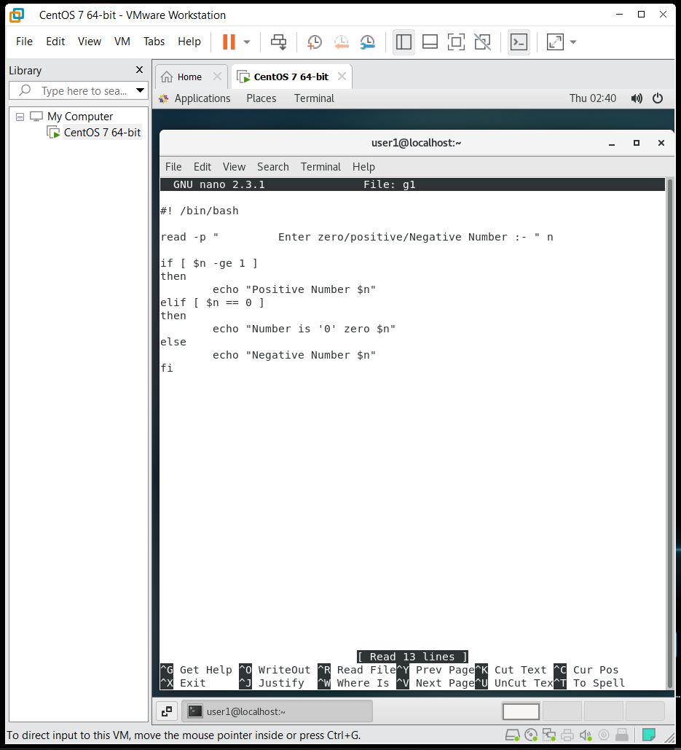

***Output:-***

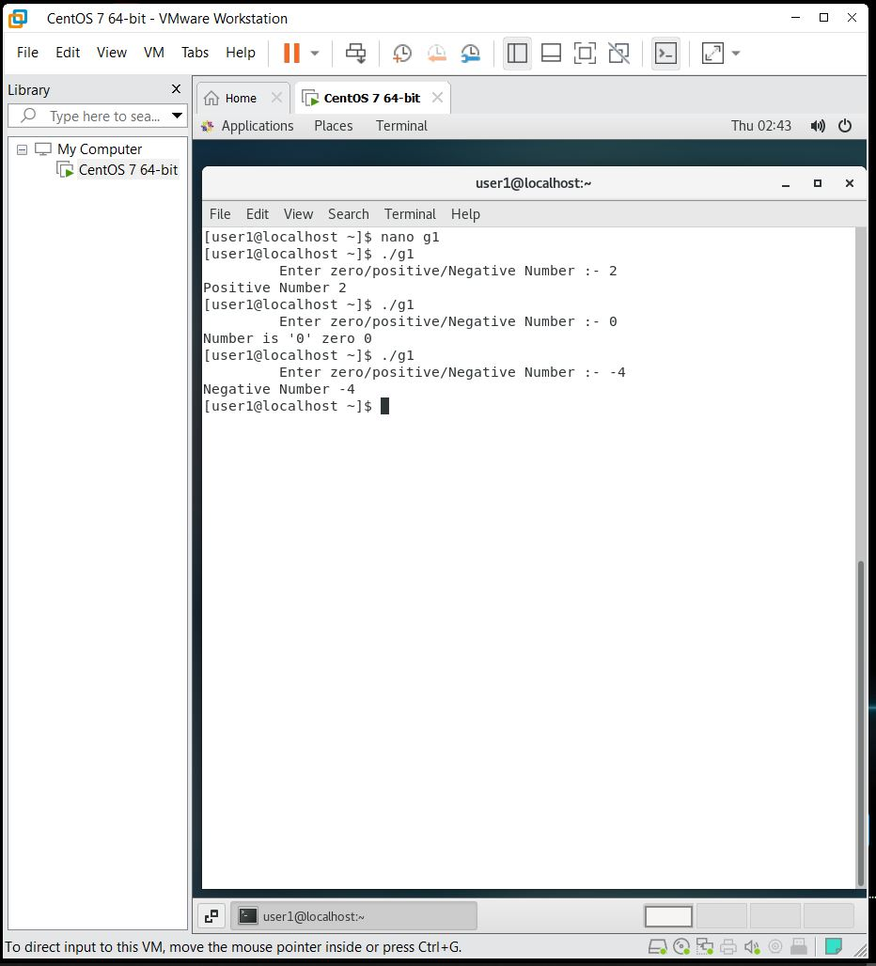

***Que 2.*** Write a shell script to check whether a given number is even or odd.

***Ans:-***

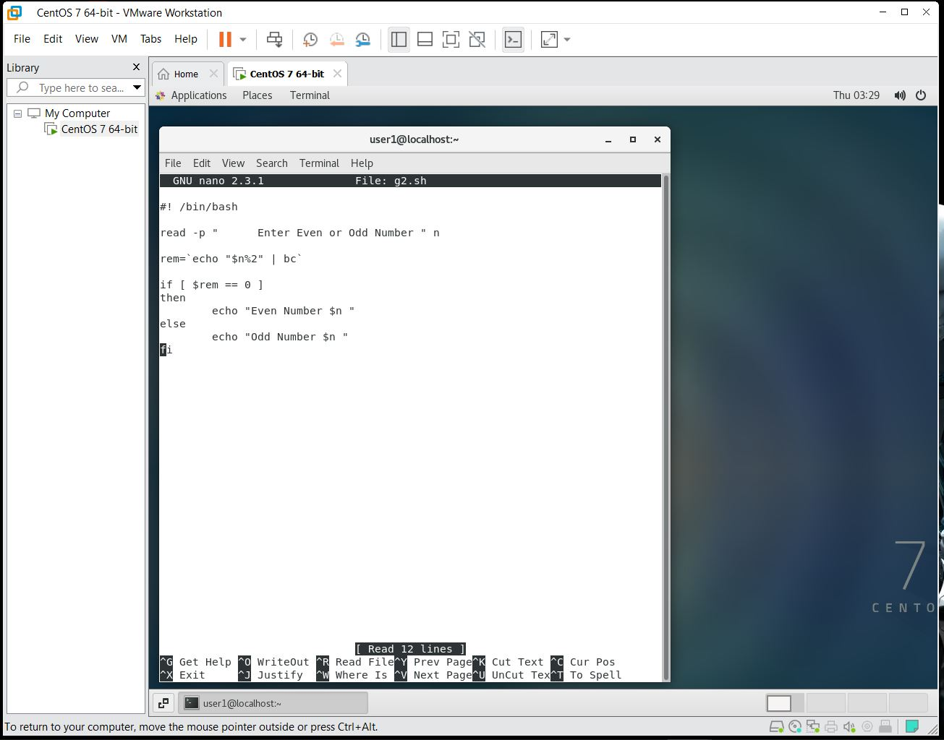

***Que 3.***

Write a shell script to find whether a given year is **leap year** or not Years divisible by 4 are leap years, with the exception of centurial years that are not divisible by 400. Therefore, the years 1700, 1800, 1900 and 2100 are not leap years, but 1600, 2000, and 2400 are leap years. Now, summarize the rules: 1. A year that is divisible by 4 is a leap year. 2. Exception to rule : a century year that is divisible by 400 is a leap year. (Century year is the year that is divisible by 100)

***Ans:-***

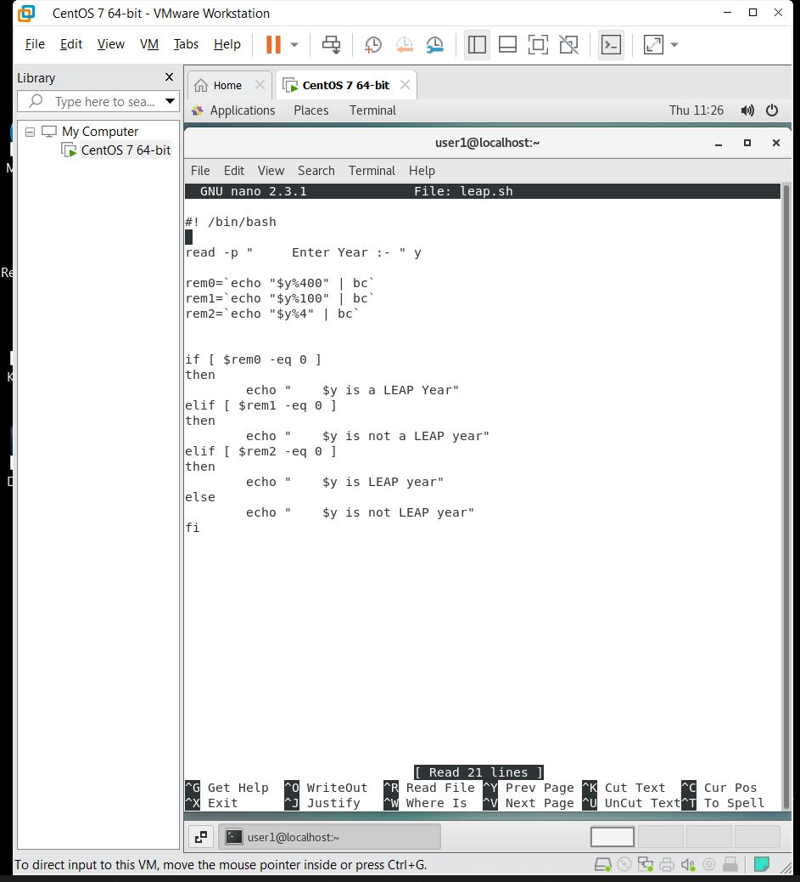

***Output:-***

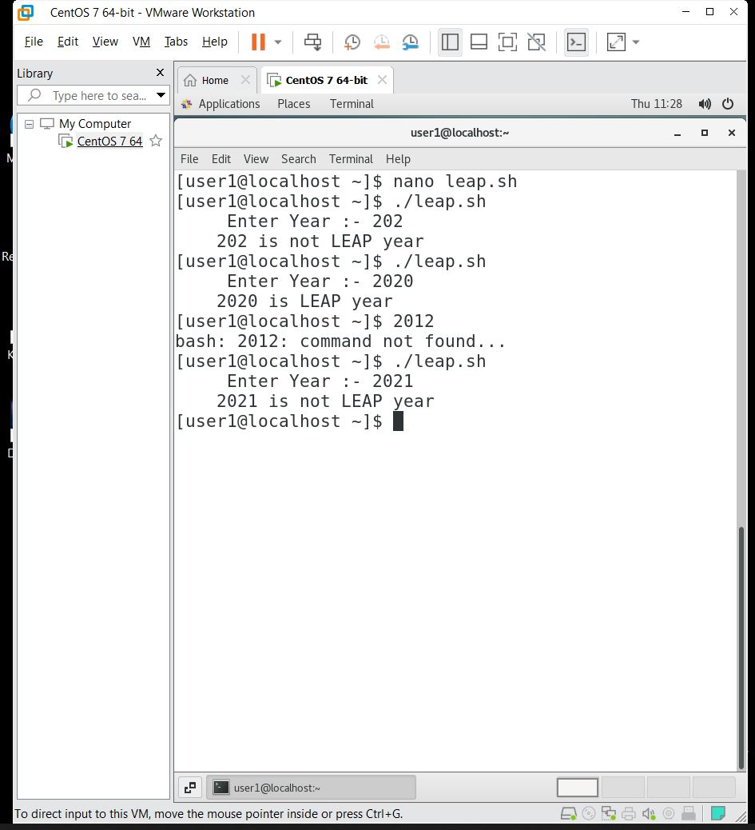

***Que 4.***  Write a shell script that will accept three numbers from command line and display the biggest among them .

***Ans :-***

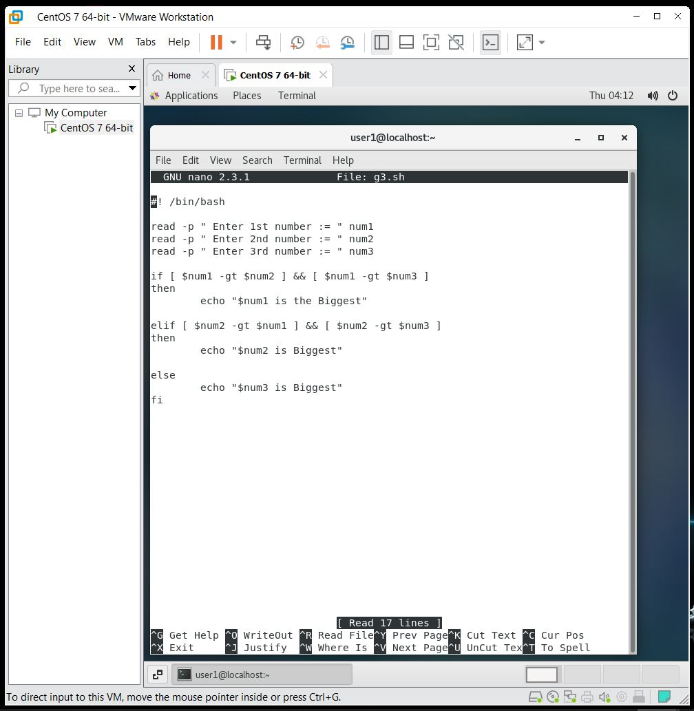

***Output:-***

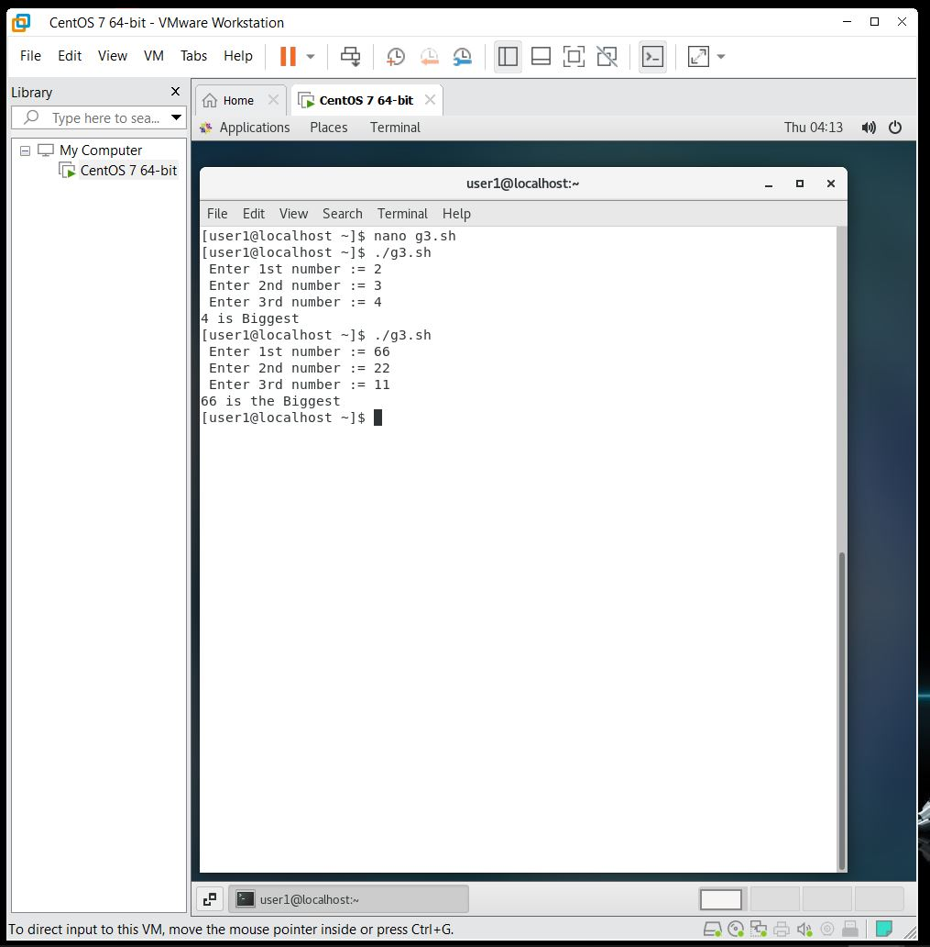

***Assignment 6 :-***

***Que 1.***.Write a shell script to perform like calculator using case.

***Ans:-***

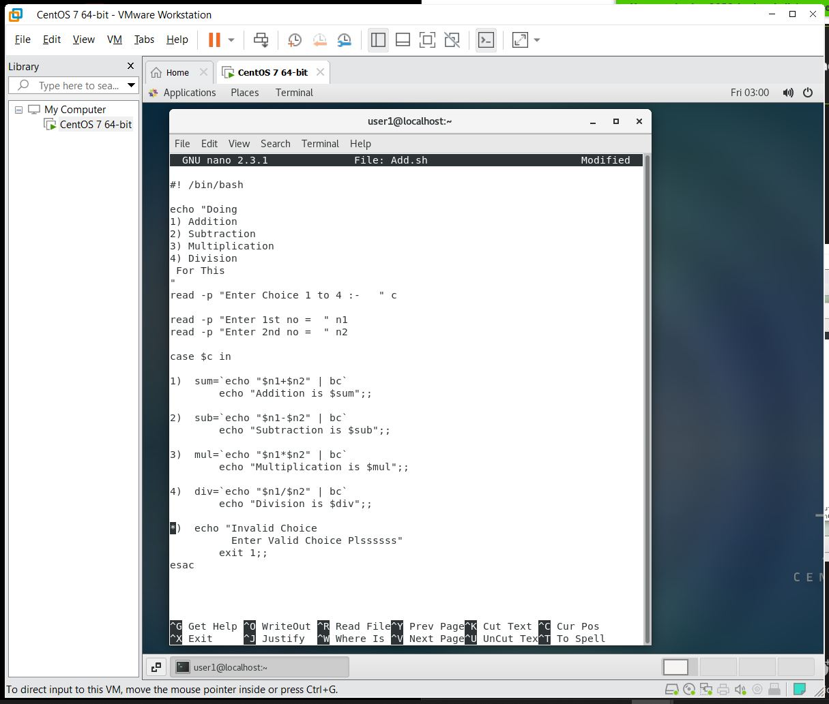

***Output:-***

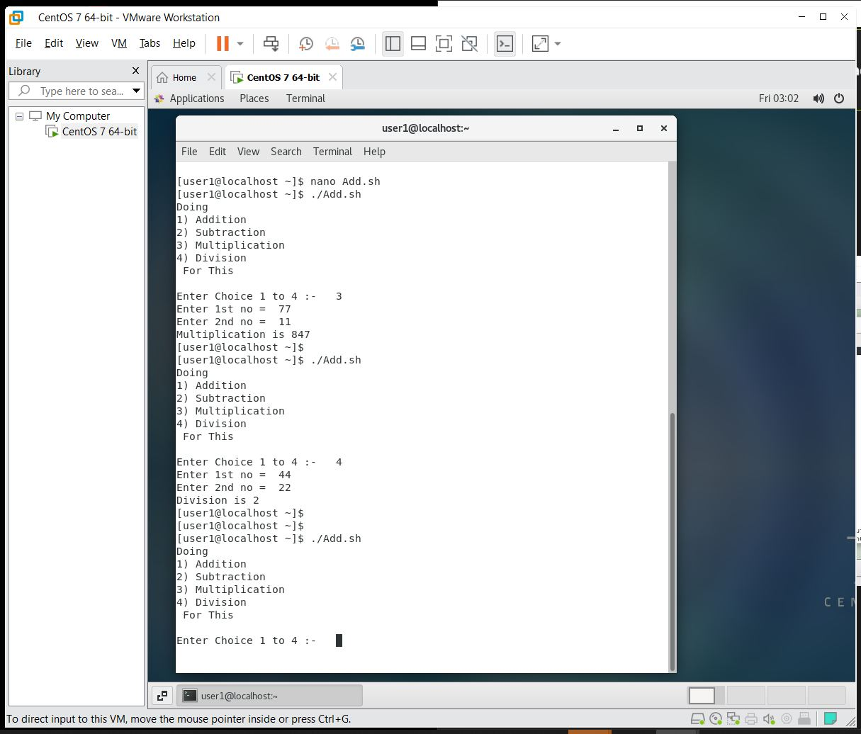

***Que 2***.Write a shell script to compute ‘m’ to the power of a positive integer ‘n’, i.e. m

***Ans:-***

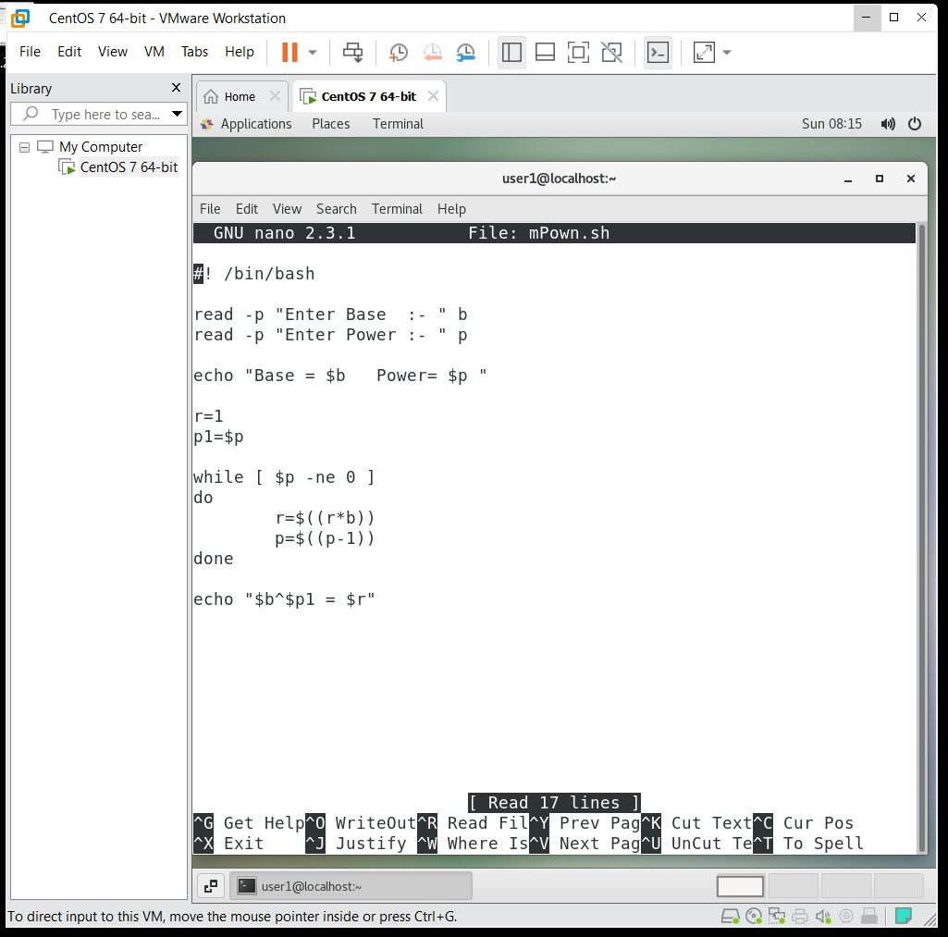

***Output:-***

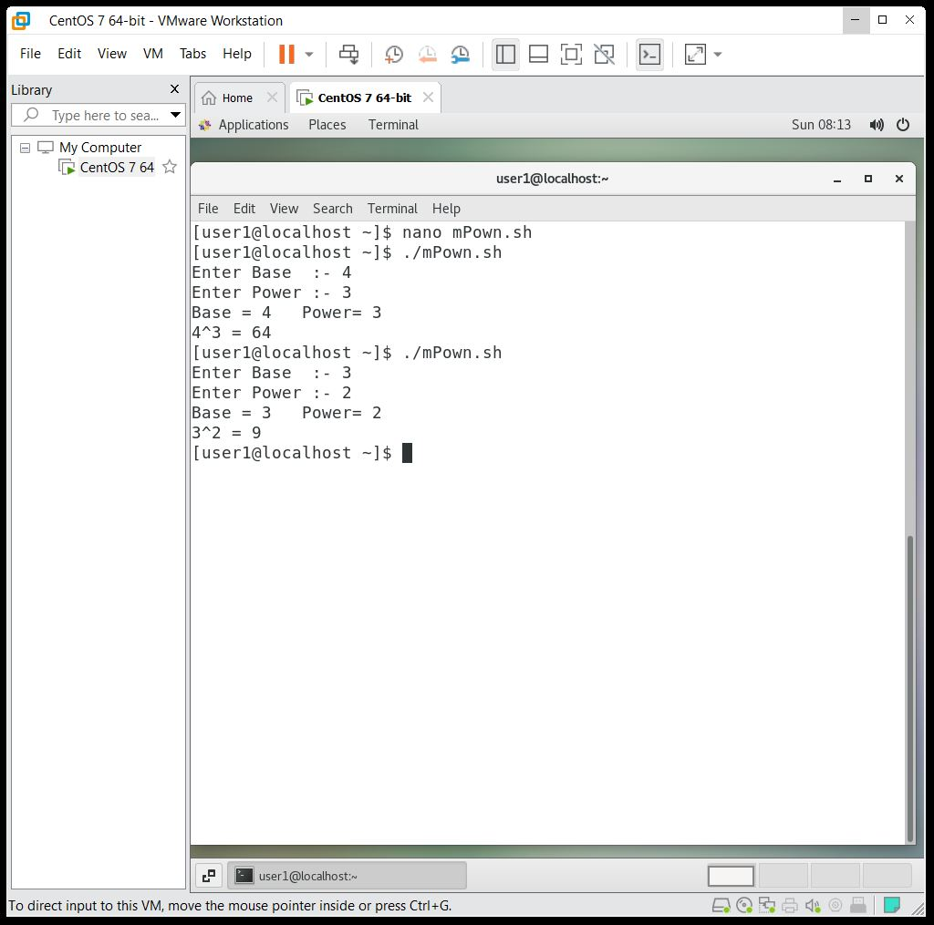

***Que 3***. Write a shell script to find the factorial of a given number.

***Ans:-***

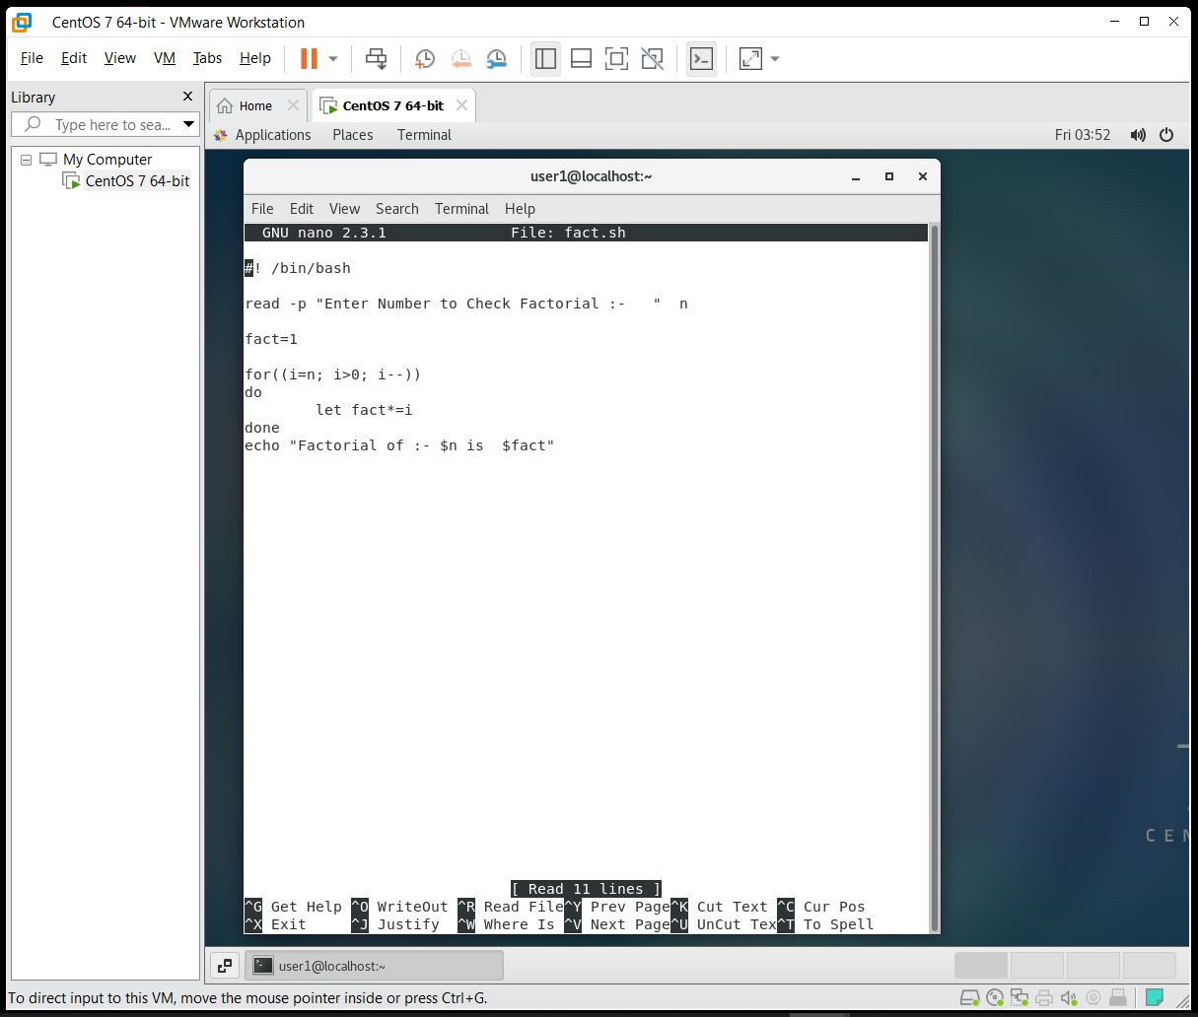

***Output:-***

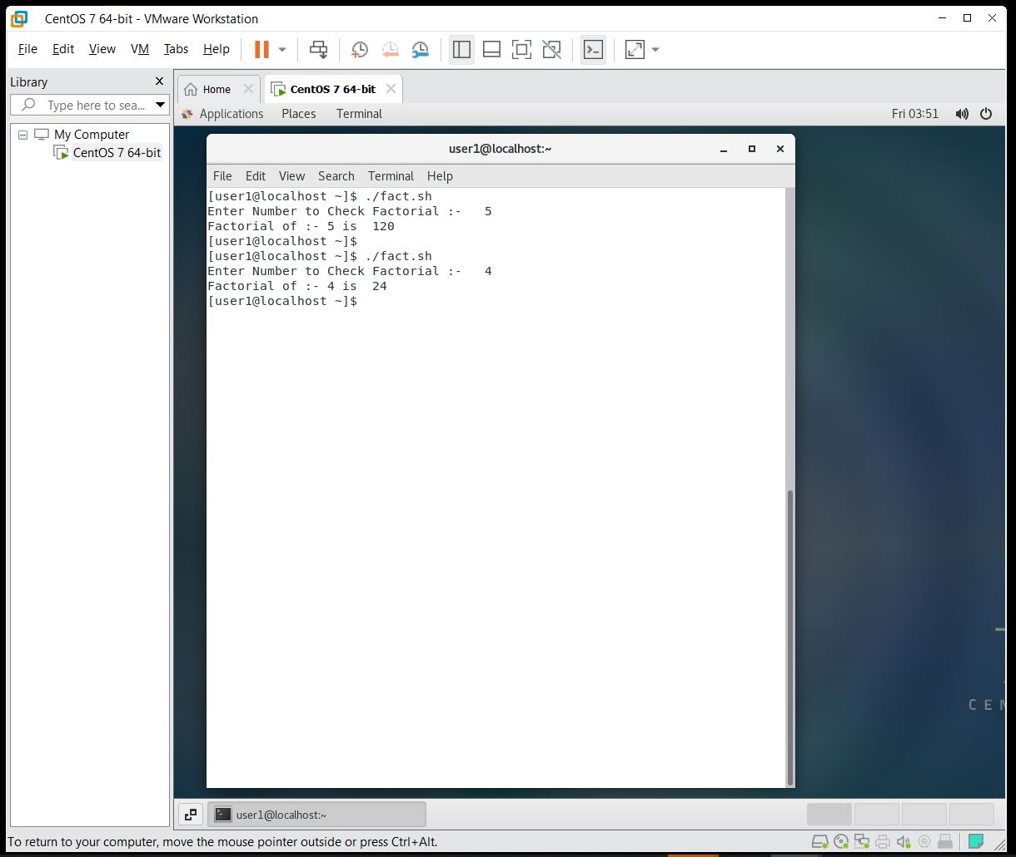

***Que 4***.Write a shell script to find the first n Fibonacci numbers

***Ans:-***

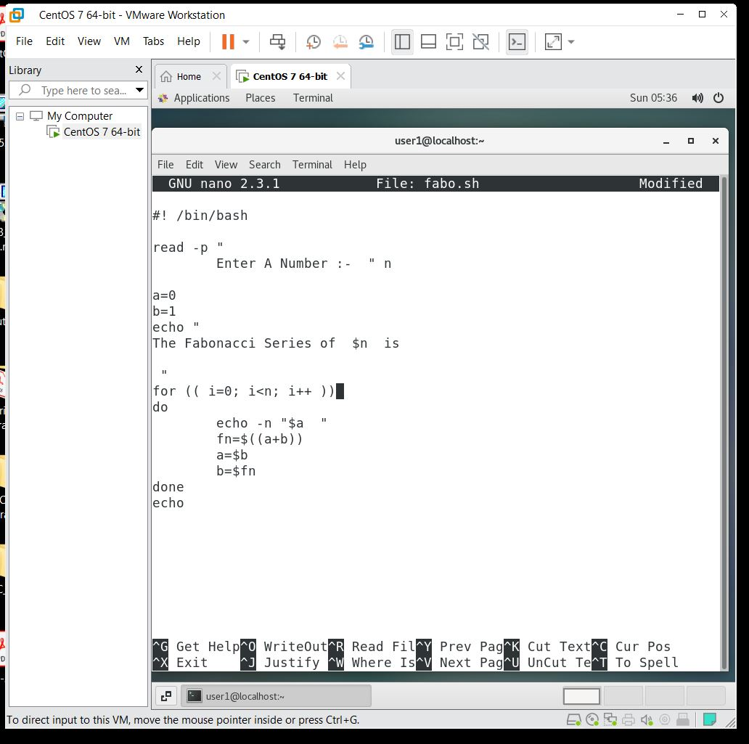

***Output:-***

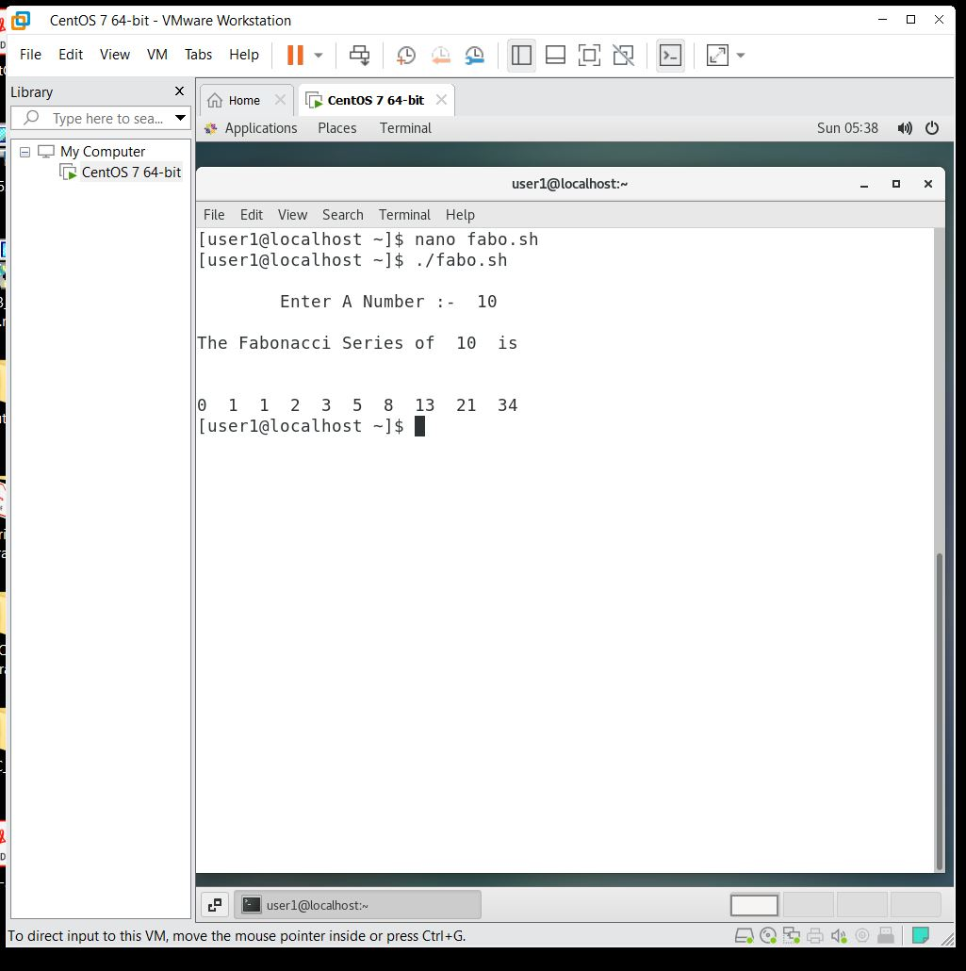

***Que 5***.Write a shell script to calculate the average of a set of N number.

***Ans:-***

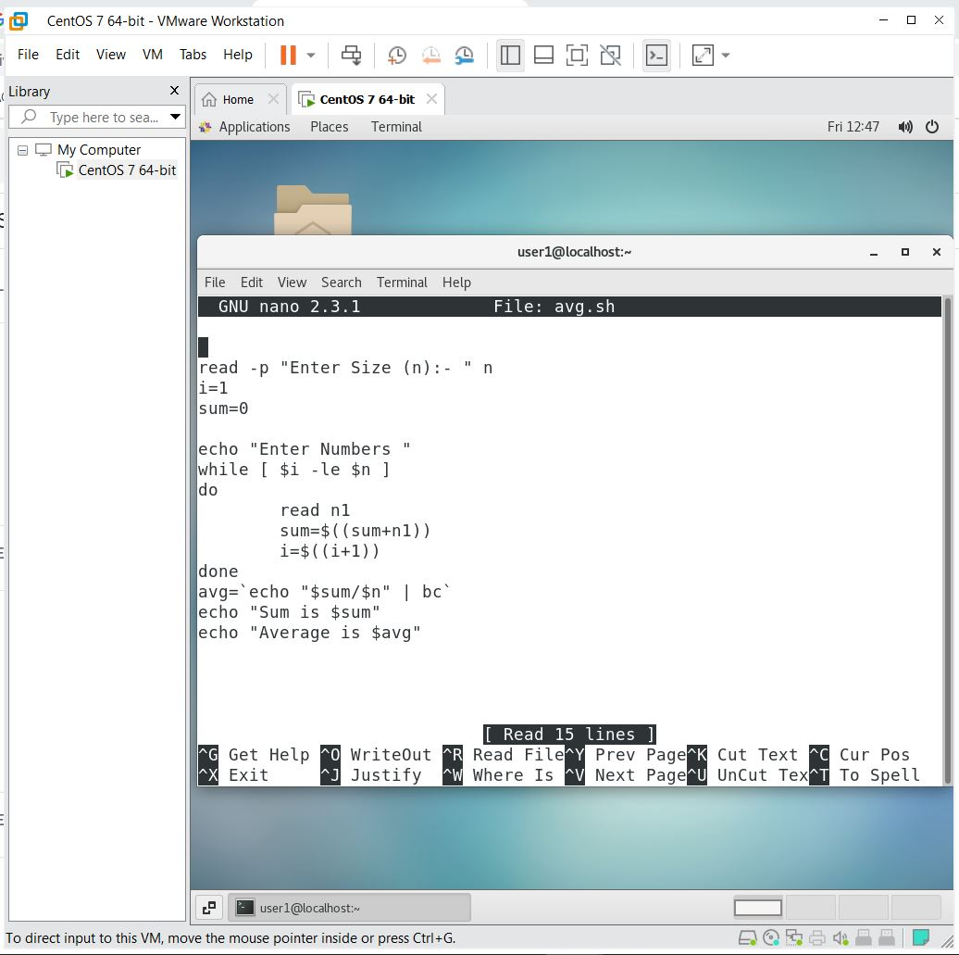

***Output:-***

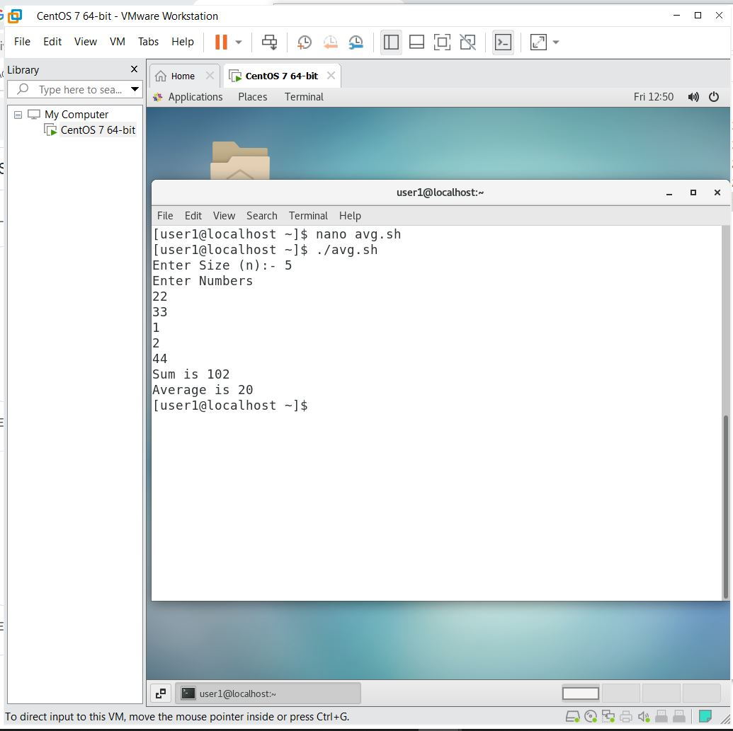

***Assignment 7 :-***

***Que 1.*** Write a shell script to find out how many file and directory are their in current directory. Also list the file and directory name separately.

***Ans:-***

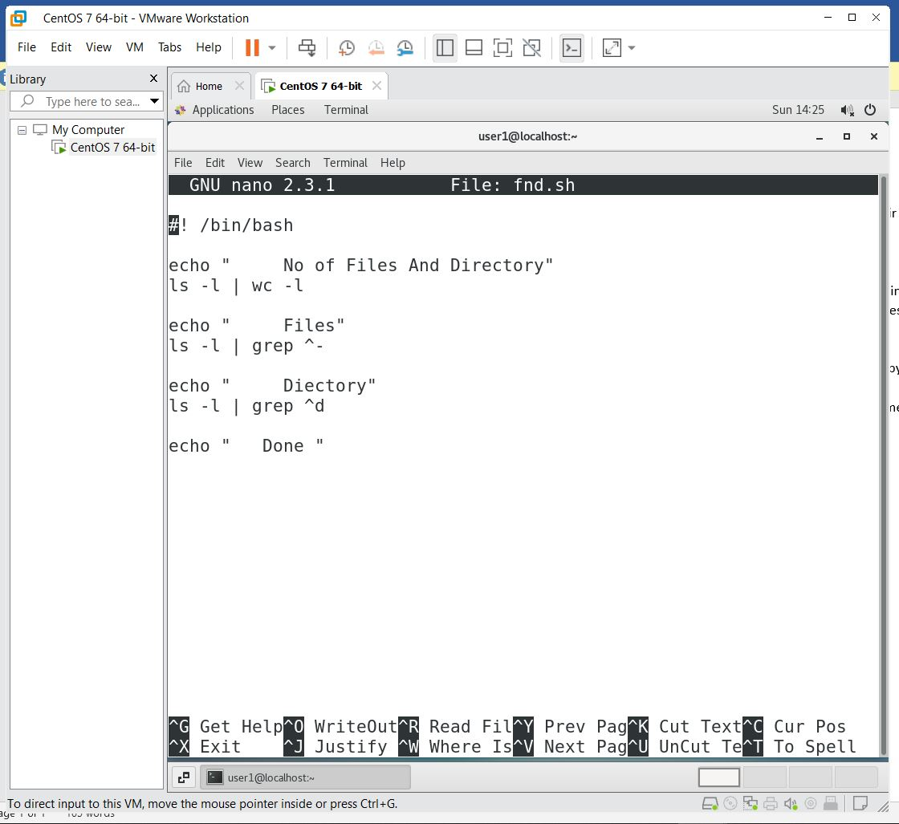

***Output:- 1-***

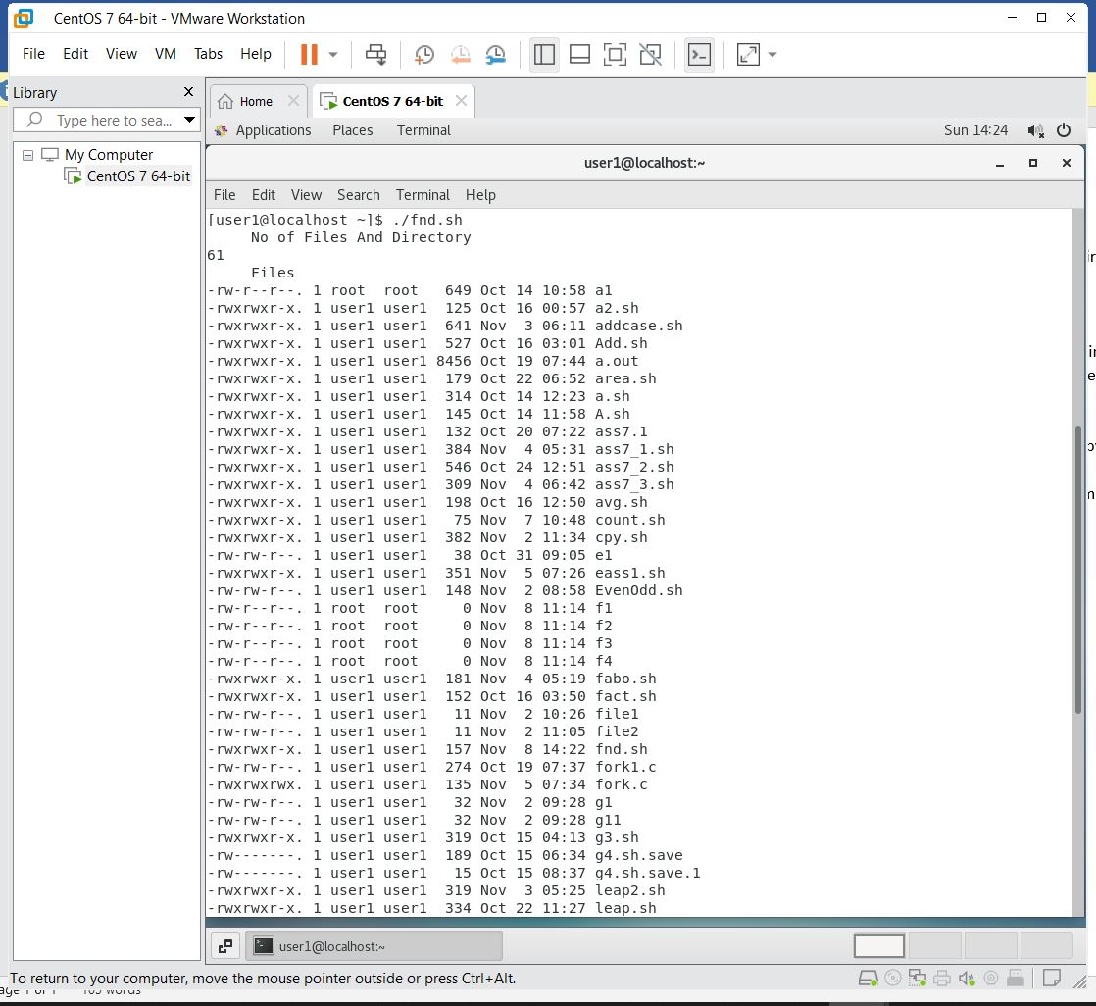

***Output:- 2-***

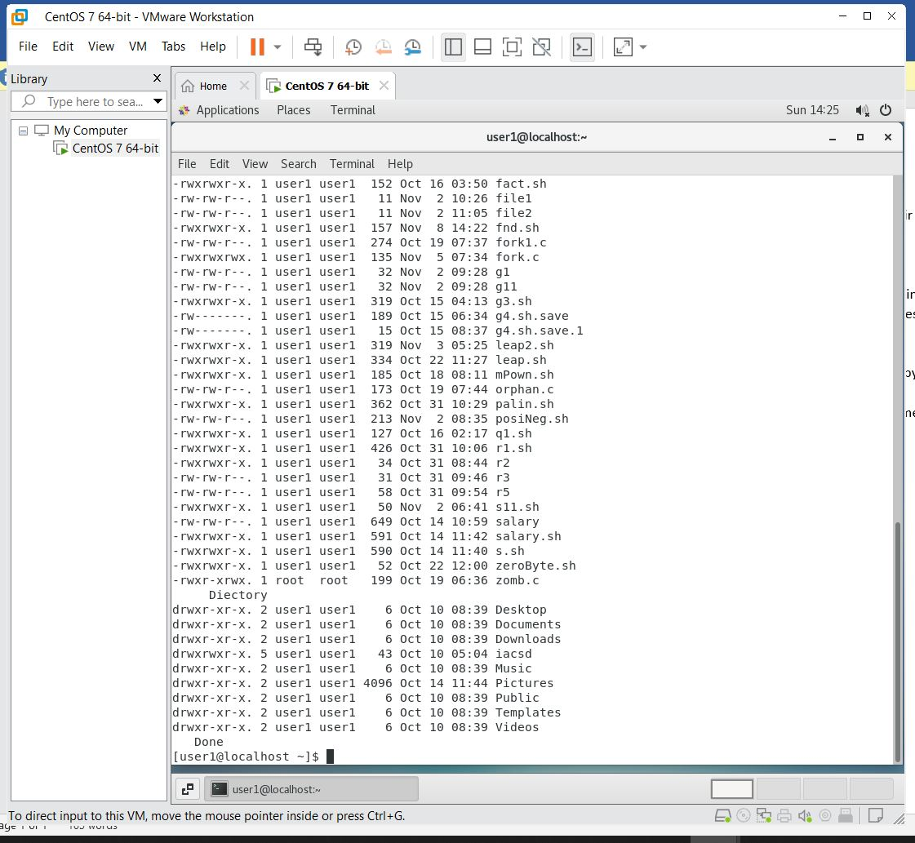

***Que 2.***Write a scripts which copies the content of file1 to file2 without using cp command It should check If file has a read permissions if not it should print an error message. If file2 exits then it should ask the user whether he wants to overwrite it.

***Ans :-***

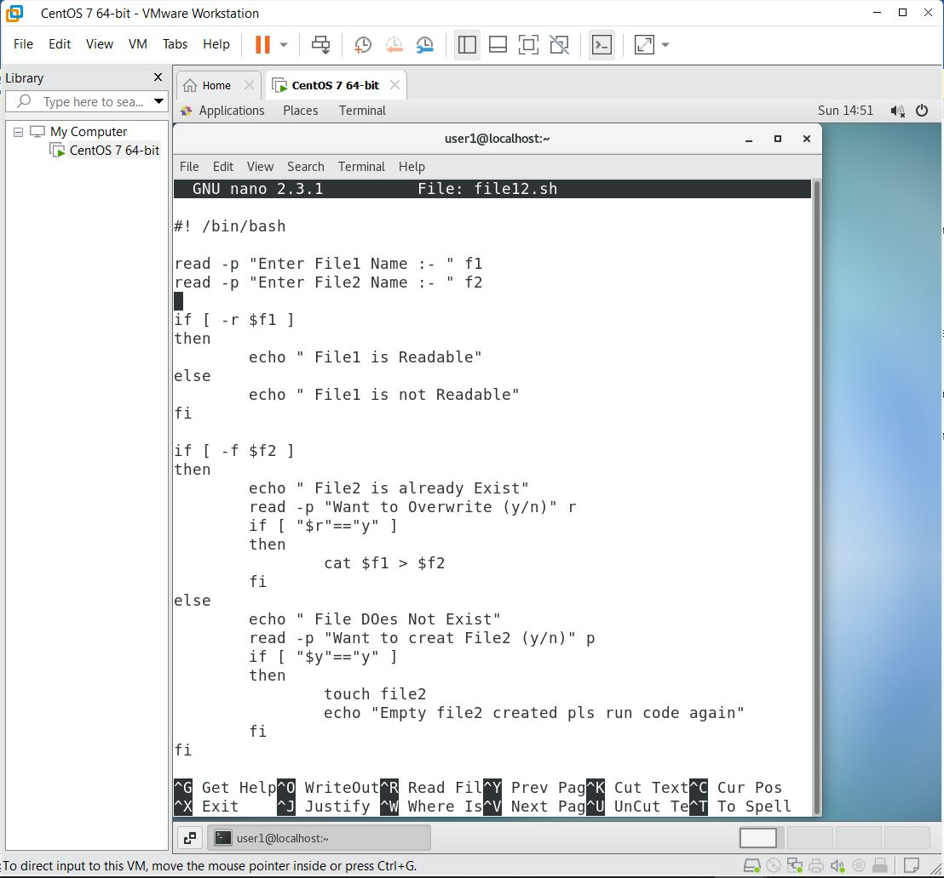

***Output:-***

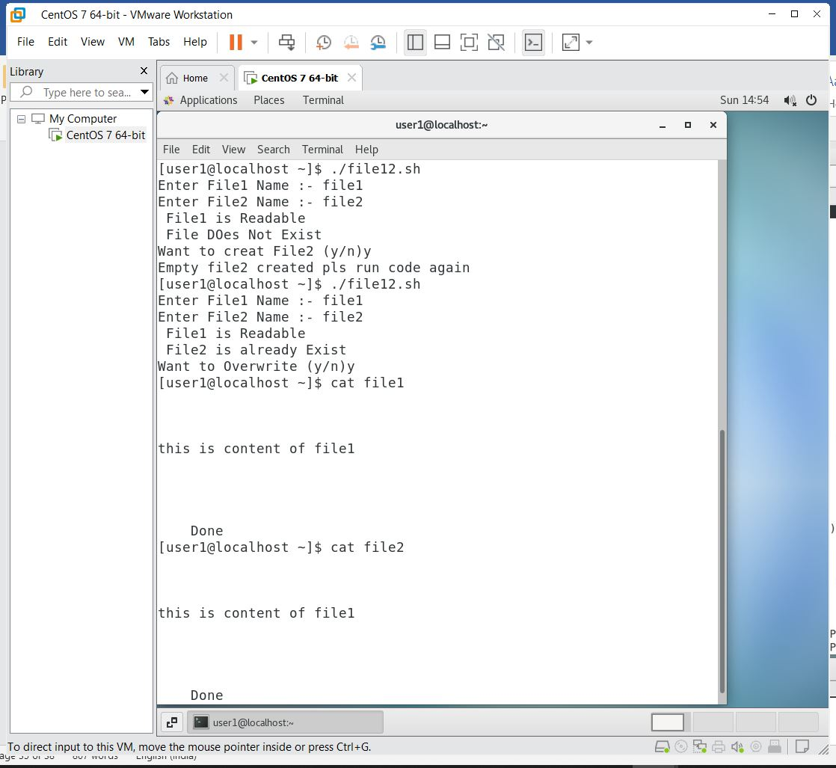

***Que 3.***Write a shell scripts that delete all files in current directory with 0 byte.

***Ans:-***

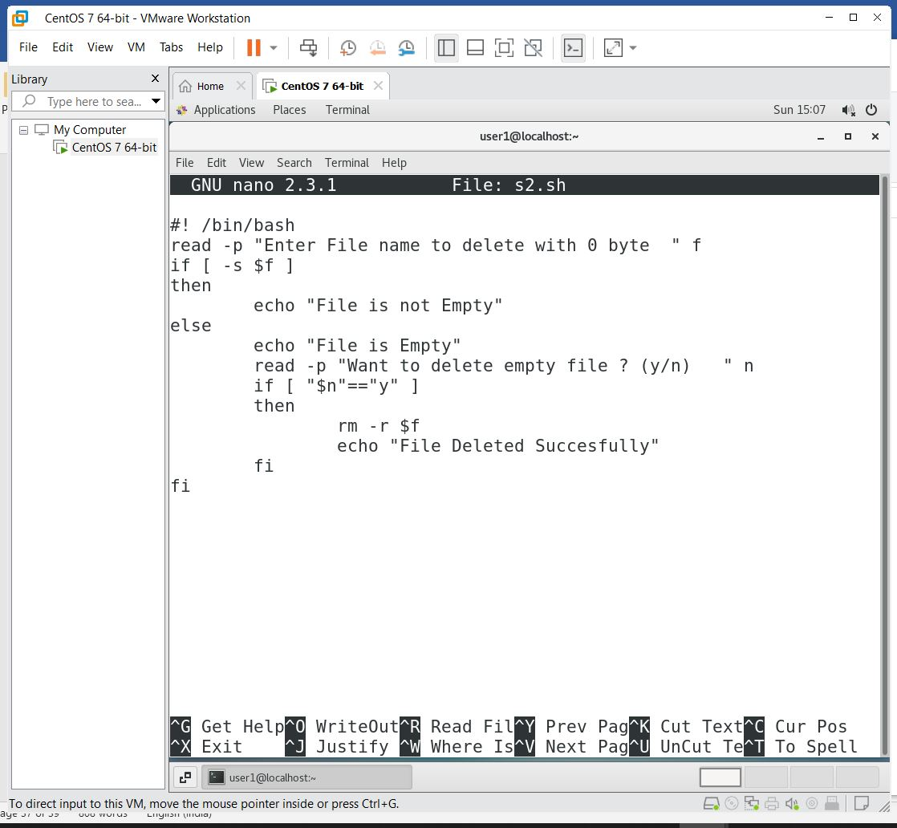

***Output:-***

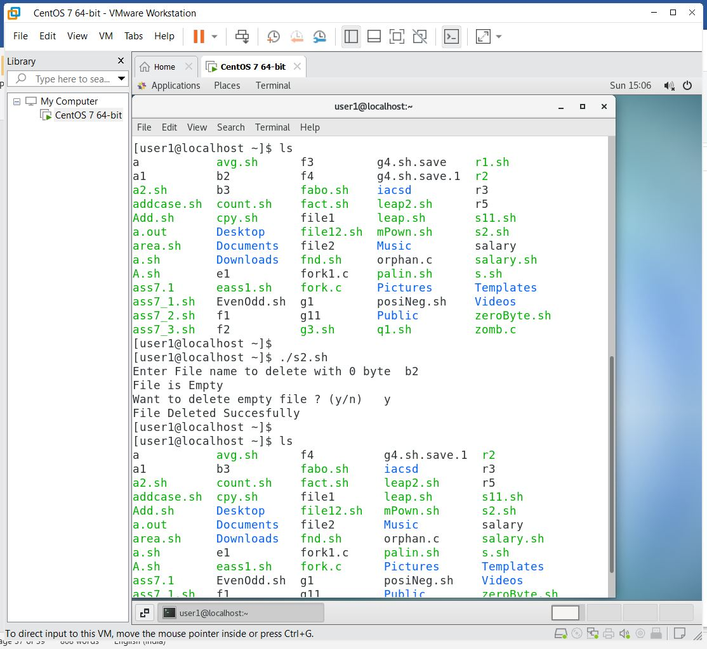

***Que 4.***Write a shell script to check whether a given number is a palindrome or not.

***Ans:-***

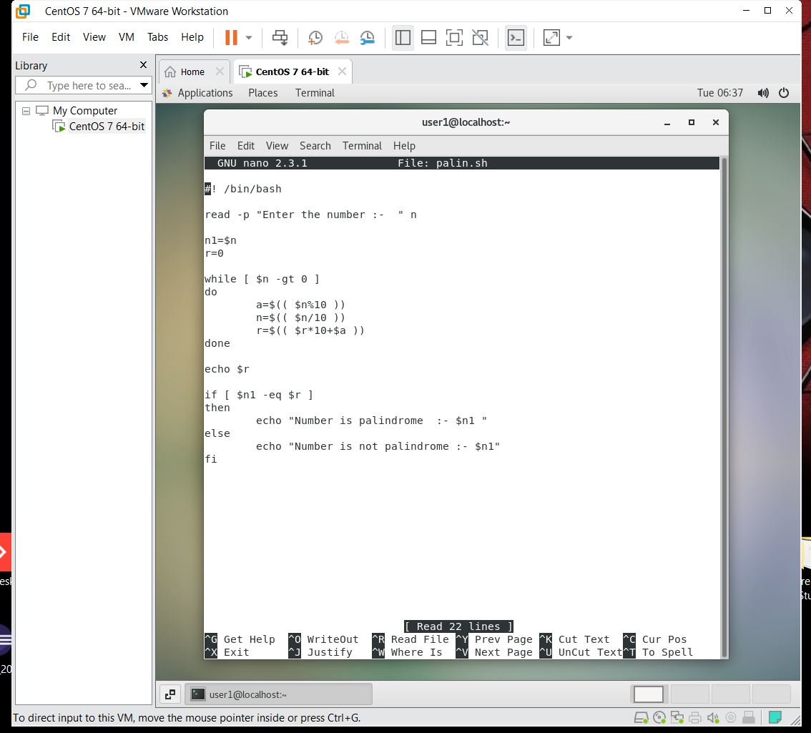

***Output:-***

